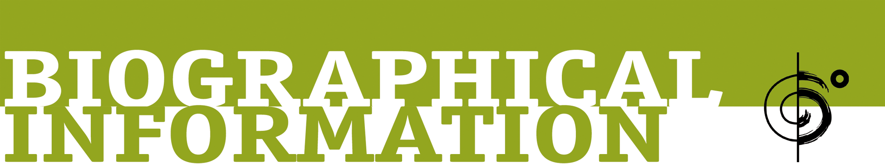

The Silver Lake Chorus performs choral arrangements of indie music and exudes both the edgy, independent spirit of Los Angeles's Silver Lake neighborhood and the heart of community choral singing.

In 2010, Australian singer Ben Lee attended a rehearsal of the recently-formed group and sat among TSLC members as they sang their cover of Beck’s “Lonesome Tears." Blown away by how the song had been “reinvented into this massive Russian Gregorian chant," Lee suggested the chorus take a completely original indie rock approach to the ancient choral art form. He signed on to produce their debut album and reached out to other artists and friends, asking them to write new music for the chorus. Ben Gibbard of Death Cab for Cutie, Wayne Coyne and Stephen Drozd of The Flaming Lips, John Roderick of The Long Winters, Inara George and Greg Kurstin of The Bird and the Bee, A.C. Newman of The New Pornographers, Aimee Mann, Sia, Tegan and Sara, and Justin Vernon of Bon Iver all responded with songs.

The resulting eponymous debut album was a distinctly unique musical experience, giving original indie rock songs a lush and highly-tailored choral treatment. Some songs were performed entirely a cappella, while others included drums, synths, string arrangements and other instrumental touches.

Press and radio took notice, with The Wall Street Journal declaring that TSLC was “changing the way people think about choruses," and Philthy Magazine stating, “Of all of the long-awaited debut LPs to come out in 2015, The Silver Lake Chorus’ self-titled full-length has proven to be the most worth getting excited about." In addition, the chorus was featured on WNYC’s Studio 360, along with album contributor Aimee Mann, and on the syndicated show World Cafe.

As TSLC prepares for their next full studio release (with outreach to a new crop of songwriters already underway), Six Degrees Records has collaborated with The Silver Lake Chorus to put the beautiful tracks from their debut into the hands of a diverse and talented cast of remixers, who’ve taken the material in new and exciting directions.

Music director and co-arranger for the chorus, Mikey Wells, says, "It was such a purely fun process to receive remixes and listen to different artists' take on our material. It's like if you went home and someone else had perfectly rearranged all of the furniture in your house and painted the walls different colors."

Soprano and co-arranger for the group, Heather Ogilvy, adds, "Because The Silver Lake Chorus album is comprised of a collection of songs re-imagined for a chorus to begin with, it seemed like a natural extension of the project to then open those tracks up for further creative re-imagining. Like a really good game of musical telephone."

From the remix project’s very first track, we can tell that we are in the hands of expert texturalists. The Nashville-based guitar duo Hammock take the Aimee Mann and Paul Bryan penned “Easy to Die" and bathe it in haunting strings and ambient washes, framing the voices in achingly beautiful melancholy. The track returns as an instrumental at the album’s close, providing a kind of wordless coda for the project.

Artist/producer Carmen Rizzo continues the sublime mood with his remix of Justin Vernon’s “From the Snow-Tipped Hills." Rizzo was a founding member of Six Degrees act Niyaz and has brought his production skills to such diverse artists as Seal, Coldplay, Alanis Morissette and Pete Townshend. He has also released a series of fine solo albums under his own name. For his “Snow-Tipped Hills” remix, Rizzo utilizes the Chorus’s original vocals in an almost chant-like way, creating a serene mantra to greet a new morning.

Also on the more ambient tip is Delia Derbyshire Appreciation Society’s remix of “Home Come Home,” titled “Robots Come Home.” Ambient veteran Harvey Jones mixes a robotic, processed voice with untreated vocals from the chorus, creating a strangely haunting and original homage to the concept of “home.”

Interestingly, Nicholas Johns, the producer who calls himself Blade Foley, also uses a similar approach to processed “robotic” vocals on his 80s-influenced remix of John Roderick’s “Same Song,” adding a saxophone solo that wouldn’t seem out of place on the soundtrack to Miami Vice. According to Heather Ogilvy: "The ‘Same Song’ Showtime After Dark remix is a personal favorite. In addition to just loving the sound world, I really like how it restructures the song. And of course when I heard the saxophone, it was an immediate ‘yes’ for me.”

Two other remixes of note are the very different readings of Wayne Coyne and Stephen Drozd's Flaming Lips composition, “Heavy Star Movin’.” First up, Japanese producer Shinya Mizoguchi (who records as starRo), combines chopped up jazzy breaks with chilled electronics that really accentuate the song’s dream-like qualities. Mikey Wells says of the mix, "I love the total liberty and creativity taken in the starRO remix. It takes the inherent spacey, trippy vibe of the original track and totally reinvents it.” Later in the album’s sequence, guitar experimentalist and soundtrack composer, David Torn weaves cinematic strings, jazzy bass and an insistent rhythm track with the chorus’s angelic voices to hypnotic effect. You have to believe that The Flaming Lips would heartily approve of both versions.

The project is rounded out by contributions from artist and soundtrack composer Ben Lovett (who records as both Lovett and Lovers & Friends), veteran drummer and producer Denny Fongheiser (Groovesoup), and newcomer Grant Marr (Growing Boy). The end result offers a fresh look at The Silver Lake Chorus’s debut, written by some of alternative music’s finest composers and now re-imagined to explore new and exciting sonic terrain.

Music director Mikey Wells sums things up nicely, saying, "I love when things are re-contextualized. Take the basic elements, find another way to make it interesting or beautiful from a different angle. That's also essentially what our album is."

Missing Piece Group:
John Hammond, t: 862-234-0801, john@missingpiecegroup.com
Brett Loeb, t: 862-234-0801, brett@missingpiecegroup.com
Six Degrees Records:
Rocco Tyndale, t: 415-626-6334, rocco@sixdegreesrecords.com

